CRChart



NAME

PHONE NUMBER

E-MAIL ADDRESS

BUSINESS NAME

ADDRESS

CITY

STATE / ZIP

COUNTRY

Payment Method
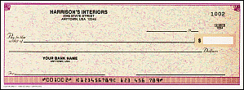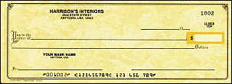
Visa Master card American Express Check Money order

Card Number: _________________________________________________________________________________

Name on Card: __________________________________________________________ Exp. Date: ___________

YES, send me ___ copy(s) of CRChart for only $499.00 each.
Includes ONE developer seat license and 60-days free unlimited tech. support.

I also need ____ additional Developer Seat Licenses at the price of $150.00 per developer seat.

I would also like a ONE year support/upgrade contract at the price of $150.00.

I understand I will be charged sales tax inside California.



THREE |D| GRAPHICS
11340 West Olympic Blvd Suite #352 Los Angeles, CA 90064-1661
(310) 231-3330 FAX (310) 231-3303
www.threedgraphics.com

